LAB 7

Secret-Key Encryption

Task 1: Frequency Analysis

* Generate the encryption key and convert all upper cases to lower cases, and then removed all the punctuations and numbers.

[03/18/22]seed@VM:~/.../Files$ ./seckey.py

**tqnvmaxwjlegrciopdkzfusybh (SECRET KEY)**

[03/18/22]seed@VM:~/.../Files$ tr ’abcdefghijklmnopqrstuvwxyz’ ’tqnvmaxwjlegrciopdkzfusybh’ < plaintext.txt > ciphertext.txt[03/18/22]seed@VM:~/.../Files$ ./freq.py

* By using the tr command above, plaintext.text was encrypted to generate ciphertext.txt

* Frequency was analysed using the freq.py which was provided on the generated ciphertext.txt

* Using tr command, we found out the plaintext from cipher text through continuous inspection we get the output.

Task 2: Encryption using Different Ciphers and Modes



* As seen above, encryption was done using **-aes-128-cbc, -aes-128-cfb & -aes-128-ctr** respectively.

Task 6: Initial Vector (IV) and Common Mistakes

* Task 6.1. IV Experiment

We created messages for P1 and P2, encrypted them with the OFB mode, and then used the xor.py tool from the book to xor the hex strings of the ciphertexts and plain texts. After doing so, the message from P2 appeared meaning we are successful. The command used are listed below:

* Task 6.2. Common Mistake: Use the Same IV

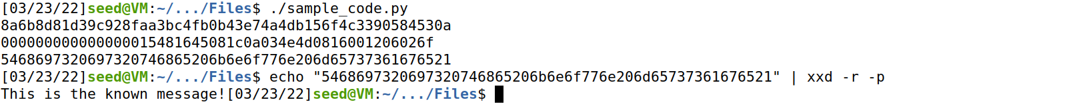

* Task 6.3. Common Mistake: Use a Predictable IV

* Bob's cipher text is comparable to the cipher text for the message "Yes"(5965730a in HEX).

Task 7: Programming using the Crypto Library

